

oneM2M
Technical Report
Document Number | oneM2M-TR-0052-V-0.3.0
Document Name: | Study on Edge and Fog Computing in oneM2M systems
Date: | 2018-08-09
Abstract: | The document is a study of how to leverage Edge and Fog computing in oneM2M architecture. Based on the result of the study, it will identify possible advanced features and enhancements which the next oneM2M release(s) could support.
Template Version: January 2017 (Do not modify)

The present document is provided for future development work within oneM2M only. The Partners accept no liability for any use of this report.
The present document has not been subject to any approval process by the oneM2M Partners Type 1. Published oneM2M specifications and reports for implementation should be obtained via the oneM2M Partners' Publications Offices.

About oneM2M
The purpose and goal of oneM2M is to develop technical specifications which address the need for a common M2M Service Layer that can be readily embedded within various hardware and software, and relied upon to connect the myriad of devices in the field with M2M application servers worldwide.
More information about oneM2M may be found at: http//www.oneM2M.org
Copyright Notification
© 2017, oneM2M Partners Type 1 (ARIB, ATIS, CCSA, ETSI, TIA, TSDSI, TTA, TTC).
All rights reserved.
The copyright and the foregoing restriction extend to reproduction in all media.

Notice of Disclaimer & Limitation of Liability
The information provided in this document is directed solely to professionals who have the appropriate degree of experience to understand and interpret its contents in accordance with generally accepted engineering or other professional standards and applicable regulations. No recommendation as to products or vendors is made or should be implied.
NO REPRESENTATION OR WARRANTY IS MADE THAT THE INFORMATION IS TECHNICALLY ACCURATE OR SUFFICIENT OR CONFORMS TO ANY STATUTE, GOVERNMENTAL RULE OR REGULATION, AND FURTHER, NO REPRESENTATION OR WARRANTY IS MADE OF MERCHANTABILITY OR FITNESS FOR ANY PARTICULAR PURPOSE OR AGAINST INFRINGEMENT OF INTELLECTUAL PROPERTY RIGHTS. NO oneM2M PARTNER TYPE 1 SHALL BE LIABLE, BEYOND THE AMOUNT OF ANY SUM RECEIVED IN PAYMENT BY THAT PARTNER FOR THIS DOCUMENT, WITH RESPECT TO ANY CLAIM, AND IN NO EVENT SHALL oneM2M BE LIABLE FOR LOST PROFITS OR OTHER INCIDENTAL OR CONSEQUENTIAL DAMAGES. oneM2M EXPRESSLY ADVISES ANY AND ALL USE OF OR RELIANCE UPON THIS INFORMATION PROVIDED IN THIS DOCUMENT IS AT THE RISK OF THE USER.

Contents
1 Scope 5
2 References 5
2.1 Normative references 5
2.2 Informative references 5
3 Definitions, symbols and abbreviations 6
3.1 Definitions 6
3.2 Symbols 7
3.3 Abbreviations 7
4 Conventions 8
5 Introduction 8
6 Analysis Background 8
6.1 Overview 8
6.2 Existing Technologies 8
6.2.1 NIST Framework 8
6.2.1.1 Introduction 8
6.2.1.2 Fog Computing Framework 9
6.2.1.3 Architectural terminology 10
6.2.2 OpenFog Consortium 11
6.2.2.1 Introduction 11
6.2.2.2 Reference Architecture 11
6.2.2.3 Development Viewpoint 13
6.2.2.4 Software View 14
6.2.2.4.1 Software Backplane 15
6.2.2.4.2 Node Management (In Band) 15
6.2.2.4.3 Application Support 16
6.2.2.4.4 Application Service Layer 17
6.2.3 ETSI ISG MEC Architecture and APIs 18
6.2.3.1 Introduction 18
6.2.3.2 MEC Framework and Reference Architecture 18
6.2.3.3 MEC API Specifications 20
6.2.3.3.1 Generic set of API design principles and patterns, “GS MEC 009” [i.7] 21
6.2.3.3.2 System, Host and Platform management APIs, “GS MEC 010-1” [i.8] 21
6.2.3.3.3 Application lifecycle management (LCM) APIs, “GS MEC 010-2” [i.9] 21
6.2.3.3.4 Application Enablement API, ”GS MEC 011” [i.10] 22
6.2.3.3.5 Radio Network Information service (RNIS) API, ”GS MEC 012” [i.11] 22
6.2.3.3.6 Location service (LS) API, ”GS MEC 013” [i.12] 23
6.2.3.3.7 UE Identity service API, “GS MEC 014” [i.13] 23
6.2.3.3.8 Bandwidth Management service (BWMS) API, “GS MEC 015” [i.14] 24
6.2.3.3.9 UE application interface, “GS MEC 016” [i.15] 24
6.2.4 Technology x 24
7 oneM2M Architectural Framework 24
7.1 Introduction 24
7.2 oneM2M Platform Optimization Scenarios 24
7.3 Architectural Models and Assumptions 24
7.3.1 Model A 25
7.3.1.1 Introduction 25
7.3.1.2 Proposed Terminology 25
7.3.1.3 Deployment Example 26
8 Analysis 26
8.1 Key Issue 1 26
8.2 Key Issue N 26
9 Proposed Solutions 26
9.1 Solution A 27
9.1.1 Solution Applicability 27
9.1.2 Solution Description 27
9.2 Solution X 27
10 Conclusions 27
I. Annexes 27
III. History 28

Scope
The present document studies how to Edge and Fog computing leverage in oneM2M architecture. It also includes architectural and gap analysis, including key issues and solutions. Based on the result of the study, it will identify possible advanced features and enhancements which the next oneM2M release(s) could support.

References
The following text block applies.
References are either specific (identified by date of publication and/or edition number or version number) or non- specific. For specific references, only the cited version applies. For non-specific references, the latest version of the referenced document (including any amendments) applies.

Normative references

Normative references are not applicable in the present document.

Informative references
Clause 2.2 shall only contain informative references which are cited in the document itself.
The following referenced documents are not necessary for the application of the present document but they assist the user with regard to a particular subject area.
[i.1] oneM2M Drafting Rules.
NOTE: Available at http://www.onem2m.org/images/files/oneM2M-Drafting-Rules.pdf.
[i.2] NIST Special Publication 800-145, The NIST Definition of Cloud Computing, September 2011 (https://csrc.nist.gov/publications/detail/sp/800-145/final)
[i.3] NIST Special Publication 800-191 (Draft), The NIST Definition of Fog Computing, August 2017 (https://csrc.nist.gov/publications/detail/sp/800-191/draft)
[i.4] OpenFog Reference Architecture for Fog Computing, February 2017 (OPFRA001.020817)
[i.5] ETSI GS MEC 002 (V1.1.1): “Mobile Edge Computing (MEC); Technical Requirements”.
[i.6] ETSI GS MEC 003 (V1.1.1): “Mobile Edge Computing (MEC); Framework and Reference Architecture”.
[i.7] ETSI GS MEC 009 (V1.1.1): “Mobile Edge Computing (MEC); General principles for Mobile Edge Service APIs”.
[i.8] ETSI GS MEC 010-1 (V1.1.1): “Mobile Edge Computing (MEC); Mobile Edge Management; Part 1: System, host and platform management”.
[i.9] ETSI GS MEC 010-2 (V1.1.1): “Mobile Edge Computing (MEC); Mobile Edge Management; Part 2: Application lifecycle, rules and requirements management”.
[i.10] ETSI GS MEC 011 (V1.1.1): “Mobile Edge Computing (MEC); Mobile Edge Platform Application Enablement”.
[i.11] ETSI GS MEC 012 (V1.1.1): “Mobile Edge Computing (MEC); Radio Network Information API”.
[i.12] ETSI GS MEC 013 (V1.1.1): “Mobile Edge Computing (MEC); Location API”.
[i.13] ETSI GS MEC 014 (V1.1.1): “Mobile Edge Computing (MEC); UE Identity API”.
[i.14] ETSI GS MEC 015 (V1.1.1): “Mobile Edge Computing (MEC); Bandwidth Management API”.
[i.15] ETSI GS MEC 016 (V1.1.1): “Mobile Edge Computing (MEC); UE application interface”.
[i.16] NFV World Congress 2017 - Enabling the 5G Cloud.
(http://www.etsi.org/multi-access-edge-computing/mec-presentations-at-industry-events)
[i.17] 3GPP TS 36.413: “LTE; Evolved Universal Terrestrial Radio Access Network (E-UTRAN); S1 Application Protocol (S1AP)”.
[i.18] 3GPP TS 36.214: "LTE; Evolved Universal Terrestrial Radio Access (E-UTRA); Physical layer; Measurements”.
[i.19] 3GPP TS 36.331:"LTE; Evolved Universal Terrestrial Radio Access (E-UTRA); Radio Resource Control (RRC); Protocol specification".
[i.20] 3GPP TS 29.171: "LTE; Location Services (LCS); LCS Application Protocol (LCS-AP) between the Mobile Management Entity (MME) and Evolved Serving Mobile Location Centre (E-SMLC); SLs interface”.
[i.21] 3GPP TS 23.401: “LTE; General Packet Radio Service (GPRS) enhancements for Evolved Universal Terrestrial Radio Access Network (E-UTRAN) access”.
[i.22] 3GPP TS 32.602: "Digital cellular telecommunications system (Phase 2+); Universal Mobile Telecommunications System (UMTS); LTE; Telecommunication management; Configuration Management(CM); Basic CM Integration Reference Point (IRP); Information Service (IS)".
[i.23] 3GPP TS 32.662: "Digital cellular telecommunications system (Phase 2+); Universal Mobile Telecommunications System (UMTS); LTE; Telecommunication management; Configuration Management (CM); Kernel CM Information Service (IS)".
[i.24] 3GPP TS 32.332: "Digital cellular telecommunications system (Phase 2+); Universal Mobile Telecommunications System (UMTS); LTE; Telecommunication management; Notification Log (NL) Integration Reference Point (IRP); Information Service (IS)".
[i.25] 3GPP TS 32.111-2: "Digital cellular telecommunications system (Phase 2+); Universal Mobile Telecommunications System (UMTS); LTE; Telecommunication management; Fault Management;Part 2: Alarm Integration Reference Point (IRP): Information Service (IS)".
[i.26] SCF 084.07.01: "Small cell zone services - RESTful bindings".
[i.27] SCF 152.07.01: "Small cell services API".
[i.28] OMA-TS-REST-NetAPI-ZonalPresence-V1-0-20160308-C: "RESTful Network API for Zonal Presence".
[i.29] OMA-TS-REST-NetAPI-ACR-V1-0-20151201-C: "RESTful Network API for Anonymous Customer Reference Management"
[i.30] MEC Deployments in 4G and Evolution Towards 5G.
(http://www.etsi.org/images/files/ETSIWhitePapers/etsi_wp24_MEC_deployment_in_4G_5G_FINAL.pdf)

Definitions, symbols and abbreviations
Delete from the above heading the word(s) which is/are not applicable.

Definitions
Clause numbering depends on applicability.
- A definition shall not take the form of, or contain, a requirement.
- The form of a definition shall be such that it can replace the term in context. Additional information shall be given only in the form of examples or notes (see below).
- The terms and definitions shall be presented in alphabetical order.
For the purposes of the present document, the [following] terms and definitions [given in ... and the following] apply:
Definition format
<defined term>: <definition>
If a definition is taken from an external source, use the format below where [N] identifies the external document which must be listed in Section 2 References.
<defined term>[N]: <definition>
example 1: text used to clarify abstract rules by applying them literally
NOTE: This may contain additional information.

Symbols
Clause numbering depends on applicability.
For the purposes of the present document, the [following] symbols [given in ... and the following] apply:
Symbol format
<symbol> <Explanation>
<2nd symbol> <2nd Explanation>
<3rd symbol> <3rd Explanation>

Abbreviations
For the purposes of the present document, the [following] abbreviations [given in ... and the following] apply:
Abbreviation format
3GPP 3rd Generation Partnership Project
API Application Program Interface
BWMS Bandwidth Management service
eNB E-UTRAN NodeB
E-RAB E-UTRAN Radio Access Bearer
ETSI European Telecommunications Standards Institute
E-UTRAN Evolved UTRAN
GTP-U GPRS Tunnelling Protocol-User plane
IaaS Infrastructure as a Service
IoT Internet of Things
IRP Integration Reference Point
LCM Life Cycle Management
LS Location Service
M2M Machine-to-Machine
NIST National Institute of Standards and Technology
NTP Network Time Protocol
OMA Open Mobile Alliance
PaaS Platform as a Service
PLMN Public Land Mobile Network
PTP Precision Time Protocol
QCI Quality Class Indicator
QOS Quality of Service
RA Reference Architecture
RAS Reliability, Availability and Serviceability
RAB Radio Access Bearer
RNIS Radio Network Information Service
SaaS Software as a Service
SCF Small Cell Forum
S-GW Serving Gateway
TEID Tunnel Endpoint Identifier
UE User Equipment

Conventions
The key words "Shall", "Shall not", "May", "Need not", "Should", "Should not" in the present document are to be interpreted as described in the oneM2M Drafting Rules [i.1].

Introduction
Editor’s Note: This section provides background information, including benefits of Edge and Fog Computing (e.g. mitigates workload of data center, provides low latency services and improves reliability). The differences between Edge and Fog might be contained in this section.

Analysis Background
Editor’s Note: The section summarizes existing technologies of Edge and Fog Computing that can be used for providing the capability enablement in oneM2M.

Overview
Editor’s Note: The section provides an overview of the technological landscape.

Existing Technologies
Editor’s Note: The section introduces existing technologies.

NIST Framework

Introduction
The National Institute of Standards and Technology's (NIST) published in 2011 one of the most widely-used working definition of cloud computing in NIST Special Publication 800-145 [i.2]. The draft and, later, the publication have been provided as contribution to other groups working to develop a standard international cloud computing definition, e.g. International Committee for Information Technology Standards (INCITS).
The NIST definition specifies:
Cloud computing: “is a model for enabling ubiquitous, convenient, on-demand network access to a shared pool of configurable computing resources (e.g., networks, servers, storage, applications and services) that can be rapidly provisioned and released with minimal management effort or service provider interaction."
Since then this work has been broadened to include other definitions and terminology for Edge and Fog computing. The aim has been to provide a tool to determine the extent to which architectures and implementations being considered meet the specified characteristics and models.
The definitions related to Fog and Edge deployments have been established by NIST to support extensions of the traditional cloud-based computing model. Because of this dependency, it is important to point out five essential characteristics of cloud computing in NIST: On-demand self-service, Broad network access, Resource pooling, Rapid elasticity and Measured Service.

Fog Computing Framework
As described in NIST Special Report 800-191 in 2017 [i.3], fog computing is seen by NIST as an extension of the traditional cloud-based computing model where implementations of the architecture can reside in multiple layers of a network’s topology and the following terminology applies:
Fog computing: Fog computing is a horizontal, physical or virtual resource paradigm that resides between smart end-devices and traditional cloud or data centers. This paradigm supports vertically-isolated, latency-sensitive applications by providing ubiquitous, scalable, layered, federated, and distributed computing, storage, and network connectivity.
Edge is the network layer encompassing the smart end- devices and their users, to provide, for example, local computing capability on a sensor, metering or some other devices that are network-accessible. This peripheral layer is also often referred to as IoT network.
In the NIST framework [i.3], the key differences between fog and edge computing can be summarized as follows:.
- Fog works with the cloud, whereas edge is defined by the exclusion of cloud and fog.
- Fog is hierarchical, where edge tends to be limited to a small number of peripheral layers.
- Fog addresses networking, storage, control and data-processing acceleration, in addition to computing.
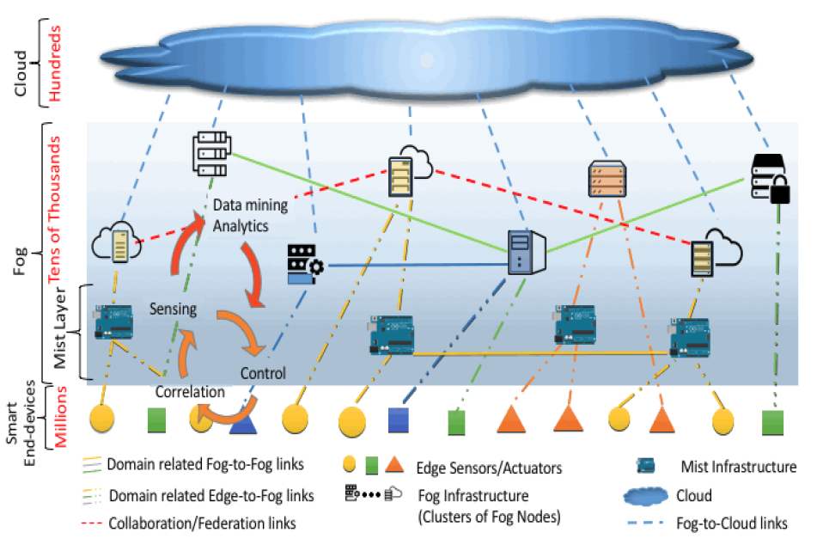
Figure 6.2.1.2-1 Fog computing within a cloud-based ecosystem for smart end-devices [i.3].
Figure 6.2.1.2-1 above depicts fog computing in the broader context of a cloud-based ecosystem serving smart end-devices, as it is important to note that, in the NIST view, fog computing is not perceived as a mandatory layer for such ecosystem.
Similarly to the five characteristics defined for cloud computing, the following characteristics define Fog deployments in the NIST model:
- Contextual location awareness and low latency. Fog nodes are closer to the IoT endpoints therefore analysis and response to data generated by the endpoints is much quicker than from a centralized cloud. Consequently, fog nodes are uniquely positioned to provide rich services at the edge of the network, including applications with low latency requirements (e.g. gaming, video streaming, and augmented reality).
- Geographical distribution. The services and applications targeted by the Fog demand widely distributed deployments, such as those needed for high quality streaming services to moving vehicles, large-scale sensor networks to monitor the environment, Smart Grids, etc.
- Very large number of nodes. As a consequence of the wide geo-distribution, this is a characteristic also evidenced in sensor networks in general, and the Smart Grid in particular.
- Support for mobility. The support for mobility techniques (e.g. the LISP protocol, that decouple host identity from location identity, and require a distributed directory system) is essential for many Fog applications in order to provide communication directly with mobile devices,
- Real-time interactions. Fog applications involve real-time interactions rather than batch processing.
- Predominance of wireless access. Fog is very well suited to wireless IoT access networks, although it may be used in wired environments as well
- Heterogeneity. Fog nodes come in different form factors and network communication capabilities, and will be deployed in a wide variety of environments.
- Interoperability and federation. Fog components must be able to interoperate in order to provide seamless support of services (e.g. real-time streaming services ) This requires also that services must be federated across domains and that the cooperation of different providers is ensured.
- Support for real-time analytics and interplay with the Cloud. Many applications require both Fog localization (enabling low latency and context awareness) and Cloud global centralization, particularly for analytics and Big Data.
As an extension of the cloud-based computing model where implementations of the architecture can reside in multiple layers of a network’s topology, the following types of service models can be implemented in Fog computing similarly to cloud:
- Software as a Service (SaaS). In this model, the fog service customer uses the fog provider’s applications running on a cluster of federated fog nodes managed by the provider. This type of service implies that the end-device or smart thing access the fog node’s applications through a thin client interface or a program interface. The end-user does not manage or control the underlying fog node’s infrastructure including network, servers, operating systems, storage, or individual application capabilities, with the possible exception of limited user-specific application configuration settings.
- Platform as a Service (PaaS). This model allows deployment of customer-created or acquired applications onto the platforms of federated fog nodes forming a cluster. Usually, the applications are created using SP supported programming languages, libraries, services, and tools. The fog service customer does not manage or control the underlying fog platform(s) and infrastructure including network, servers, operating systems, or storage, but has control over the deployed applications and possibly configuration settings for the application-hosting environment.
- Infrastructure as a Service (IaaS). This model provides the customer the capability to provision processing, storage, networks, and other fundamental computing resources of the platforms of federated fog nodes forming a cluster., The customer is able to deploy and run arbitrary software, which can include operating systems and applications. The consumer does not manage or control the underlying infrastructure of the fog nodes cluster and has limited control of select networking components (e.g., host firewalls).

Architectural terminology
This clause introduces some relevant NIST terminology. All text in italics represents direct quotes from [i.3], introduced here verbatim to inform directly the oneM2M process of establishing Edge and Fog -related concepts and definitions in the context of a M2M Service Layer.
Fog Node: Fog nodes are intermediary compute elements of the smart end-devices access network that are situated between the Cloud and the smart end-devices. Fog nodes may be either physical or virtual elements and are tightly coupled with the smart end-devices or access networks. Fog nodes typically provide some form of data management and communication service between the peripheral layer where smart end-devices reside and the Cloud. Fog nodes, especially virtual ones, also referred as cloudlets, can be federated to provide horizontal expansion of the functionality over disperse geolocations.
Private fog node. A fog node that is provisioned for exclusive use by a single organization comprising multiple consumers (e.g., business units.) It may be owned, managed, and operated by the organization, a third party, or some combination of them, and it may exist on or off premises.
Community fog node. A fog node that is provisioned for exclusive use by a specific community of consumers from organizations that have shared concerns (e.g., mission, security requirements, policy, and compliance considerations.) It may be owned, managed, and operated by one or more of the organizations in the community, a third party, or some combination of them, and it may exist on or off premises.
Public fog node. A fog node that is provisioned for open use by the general public. It may be owned, managed, and operated by a business, academic, or government organization, or some combination of them. It exists on the premises of the fog provider.
Hybrid fog node. A complex fog node that is a composition of two or more distinct fog nodes (private, community, or public) that remain unique entities, but are bound together by standardized or proprietary technology that enables data and application portability (e.g., fog bursting for load balancing between these fog nodes.)

OpenFog Consortium

Introduction
The OpenFog consortium was formed with the goal to create an open reference architecture for fog computing. The OpenFog Reference Architecture (OpenFog RA) [i.4] defined by the OpenFog consortium is a universal technical framework designed to enable the data-intensive requirements of Internet of Things, 5G and artificial intelligence applications. It is a structural and functional prescription of an open, interoperable, horizontal system architecture for distributing computing, storage, control and networking functions closer to the users along a cloud-to-thing continuum of communicating, computing, sensing and actuating entities. The OpenFog Consortium intends to partner with standards development organizations and to provide various levels of interoperability. The Consortium will be laying the groundwork (e.g., through requirements) for future component level interoperability and eventually certification. Technology used to facilitate part of a fog solution will be termed OpenFog Technology Ready.
Various use cases are introduced in the OpenFog RA, including transportation with smart cars and traffic control, visual security and surveillance, smart cities and smart buildings (as shown in Table 6.2.2.1-1). The use cases focus on the concerns in performance control, latency and efficiency, and present the advantages of OpenFog approaches such as additional security, awareness of client-centric objectives, agility of rapid innovation and scaling, real-time processing and control, and dynamic pooling of local unused resources.
Table 6.2.2.1-1: Use Cases in OpenFog RA
Use case | Highlights
Smart cars and traffic control | Multiple fog/cloud domain interactions; mobile fog nodes; multiple fog networks by different authorities; multi-tenancy across fog nodes; private and public fog/cloud networks; hierarchical and distributed architecture.
Visual security and surveillance | Support for high resolution cameras; machine vision; low latency detection and response; privacy preservation.
Smart cities | Optimized connectivity and network usage; secure data and distributed analytics.
Smart buildings | Real-time processing and responses of sensor data; hierarchical control; operational history assisted machine learning for optimization models.

Reference Architecture
The OpenFog RA defines the core driving principles as pillars, which act as the belief, approach, intent and guidance of the reference architecture, and represent the key attributes for a system to embody the OpenFog definition. The pillars include security, scalability, openness, autonomy, programmability, reliability-availability-serviceability, agility and hierarchy.
- Security pillar: The security pillar includes OpenFog node security, network security, management and orchestration security. The security pillar defines base building blocks starting from mandatory hardware root of trust on each fog node, and extending to chain of trust on other components, other fog nodes, and to the cloud, which ensures a secure end-to-end OpenFog deployment.
- Scalability pillar: The scalability pillar is defined to address dynamic technical and business needs of fog deployments, including all fog computing applications and verticals. The scaling opportunities could be found in individual fog node’s internal hardware or software, addition of fog nodes on the same or adjacent levels of the fog hierarchy, demand-driven environment, and services of storage, connectivity and analytics. The scalability may involve different dimensions in the fog networks, including performance, capacity, reliability, security, hardware and software. With the scalability pillar, fog nodes will be enabled to adapt to different workload, system cost, performance and other changing needs.
- Openness pillar: Openness is required as a foundational principle to achieve fully interoperable systems and a ubiquitous fog computing ecosystem for IoT platform and applications. The openness pillar in OpenFog RA defines several major characteristics including composability of apps and services, interoperability between different suppliers, open communication near the edge to enable resource pooling, and location transparency to allow nodes be deployed anywhere in the hierarchy.
- Autonomy pillar: The autonomy pillar requires fog nodes to be able to continue to deliver functionality in the case of external service failures. A wide range of autonomy functions are supported, such as discovery, orchestration and management, security, operation and cost savings, which do not rely on a centralized operation entity.
- Programmability pillar: Programmability pillar defines the re-tasking of a fog node or a cluster of fog nodes to accommodate operational dynamics and thus enables highly adaptive deployments. With the programmability of fog nodes, adaptive infrastructure, resource efficient deployments, multi-tenancy, economical operations and enhanced security could be achieved.
- Reliability, availability and serviceability (RAS) pillar: RAS pillar involves hardware, software and operation areas, and plays an important role in OpenFog especially in harsh environmental conditions and remote locations. The reliable aspect requires the deployment to continue to deliver functionality under both normal and adverse operation conditions. Availability, usually measured in uptime, ensures continuous management and orchestration. Serviceability ensures correct operation of the fog deployment.
- Agility pillar: Agility pillar transforms huge volumes of data generated in the fog deployments into actionable insights by creating context close to the data generation, thus enabling quick response to the highly dynamic nature of fog deployments.
- Hierarchy pillar: The hierarchy pillar is the main reason that the OpenFog architecture could become complementary to the traditional cloud-only architecture. The resources in the OpenFog RA can be viewed as a logical hierarchy based on the functional requirements, including devices, monitoring and control, operational support, surrogacy, and business support, where each layer addresses a specific concern of the system. The hierarchical fog deployments can result in different models by combining and deploying fog and cloud into different layers depending on the scenarios.
Based on the eight pillars, the OpenFog RA further describes the architecture in functional and deployment viewpoints. How the OpenFog architectural elements and views will be applied to address various concerns in a given scenario will be shown in a functional viewpoint, while how the fog systems are deployed will be defined in a deployment viewpoint. A multi-tier deployment is often exploited, where the number of tiers will be determined depending on the scenario requirements, and the fog nodes that are required to communicate within the fog hierarchy to discover, trust and utilize services of other nodes.
The OpenFog RA also provides an abstract representation of an instance of a fog node, which consists of multiple structural aspects (views) and cross-cutting concerns (perspectives), as presented in Figure 6.2.2.2-1.
Figure 6.2.2.2-1: Architecture Description with Perspectives [i.4]
Three views have been identified, including software view, system view, and node view. These views address multiple stakeholders such as a silicon manufacturer, system manufacturer, system integrator, software manufacturer and application developer.
- Node view: The node view is represented in the bottom two layers in Figure 6.2.2.2-1, including Protocol Abstraction Layer and Sensors, Actuators, and Control.
- System view: The system view is represented in the middle layers in Figure 6.2.2.2-1, including Hardware Virtualization down through the Hardware Platform Infrastructure.
- Software view: The software view is represented in the top three layers in Figure 6.2.2.2-1, which includes Application Services, Application Support, Node Management and Software Backplane.
Five perspectives are defined in the abstract architecture, including performance and scale, security, manageability, data analytics and control, IT business and cross fog applications, which are employed throughout the architecture layers.
- Performance: Low latency is one of the driving reasons to adopt fog architectures, therefore multiple requirements and design considerations are to be taken to ensure the low latency in performance, which is a cross cutting concern that impacts system and deployment scenarios.
- Security: End-to-end security is critical to all fog computing deployment scenarios, which applies to both the underlying silicon layer and the upper layer software. Data integrity is a special aspect of security for devices that currently lack adequate security.
- Manageability: Manageability is a critical aspect across all layers of a fog hierarchy that includes the managing of all aspects of fog deployments.
- Data analytics and control: The ability for fog nodes to be autonomous requires localized data analytics coupled with control. The actuation/control needs to occur at the correct tier or location in the fog hierarchy as dictated by the given scenario, which could be at the physical edge or higher tier.
- IT business and cross fog applications: Applications need to migrate and properly operate at any level of a fog deployment’s hierarchy in a multi-vendor ecosystem. Applications should also be able to span all levels of a deployment to maximize their value.

Development Viewpoint
The development viewpoint is detailed in order to provide an understanding of the deployment models considered by OpenFog and their alignment with the onM2M models.
How fog systems and fog software are deployed to address a given scenario is very important. Depending on the scenario, the deployment could be cloud independent, or leverage the cloud for the entire stack, or a combination where fog and cloud elements collapse into a single physical deployment. In most fog deployments, usually there are multiple tiers of nodes, where the number of tiers will be determined based upon the scenario requirements. The focus or roles of nodes on different tiers could differ as follows:
- Nodes at the edge: sensor data acquisition/collection; data normalization; command/control of sensors and actuators;
- Nodes in the next higher tier: data filtering, compression, transformation; edge analytics (with higher level machine and system learning capabilities);
- Nodes at the higher tiers or nearest the backend cloud: aggregate data and turn the data into knowledge (greater insights).
Nodes closer to the edge may be provisioned with less processing, communications, and storage than nodes at higher levels. Therefore, fog nodes may be linked to form a mesh to provide load balancing, resilience, fault tolerance, data sharing, and minimization of cloud communication. This may require fog nodes to have the ability to communicate both laterally (east to west) and up and down (north to south) within the fog hierarchy, as illustrated in Figure 6.2.2.3-1.
Figure 6.2.2.3-1: Fog Node Communications [i.4]

Software View
The software view of the OpenFog RA is relevant to oneM2M as the stakeholders targeted are system integrators, software architects, solution designers and application developers of a fog computing environment. The software view can be separated into three layers on top of the platform hardware layer, as shown in Figure 6.2.2.4-1 and detailed in the following clauses.
Figure 6.2.2.4-1: Software Architecture View [i.4]

Software Backplane
The software backplane layer is required to run software on the node and facilitate node-to-node communications, including OS, software drivers and firmware, communication services, file system software, software virtualization, and containerization. The software backplane layer also orchestrates thing-to-fog, fog-to-fog and fog-to-cloud communications.
Software containers provide mechanisms for fine-grained separation of applications and micro services running on the software backplane. Unlike VMs, containers do not contain/require a separate OS and multiple containers can share a kernel. The containers and the applications within a container can be restricted to use a specific amount of resources (e.g. CPU, memory, network, I/O) Therefore, containers enable the elastic compute environment needed by fog computing, which facilitates highly distributed systems by allowing multiple applications running on a single physical compute node, across multiple VMs, or across multiple physical compute nodes.
Trust is established in the software layers above the backplane by the security component of software backplane, which will provide means of verification of the application support and service layers. The software backplane ensures that containers, their application services and micro services can be securely initialized and their intended services can be provided. This layer also ensures trusted computing by protecting communications between nodes through data confidentiality, integrity and nonrepudiation
Additional functionality of the software backplane include:
- Service discovery: essential for multiple fog deployments to come together and create multiple trust boundaries in an ad-hoc manner to achieve cooperative information exchange and computation;
- Node discovery: applies to intra-fog discovery in a clustered deployment such that a node will be available for sharing the workload when its presence in the cluster is known;
- State management: support for both stateful and stateless computational models, where the former can externalize or store the state within the fog cluster;
- Publication and subscription management: support temporal and standing subscriptions and pluggable notification endpoints for publication of events, notification of state changes, and broadcast of messages.

Node Management (In Band)
The fog In Band management layer is responsible for keeping the hardware and software of the fog node or system configured to the desired state, and running at the specified levels for availability, resilience and performance. The following capabilities are provided to a fog deployment :
- Configuration management: OS and application support configuration managed through software agent that maintains desired state of the OS and the application runtime;
- Operational management: capture, store, and present operational telemetry of fog nodes for system management personnel and automated systems responsible for monitoring the infrastructure;
- Security management: include key management, crypto suite management, identity management, and security policy management;
- Capacity management: monitor the capacity and page in additional computing, networking and storage resources;
- Availability management: automatic healing in case of malfunction or crash of software or hardware by relocating workload to different hardware node.

Application Support
Application support includes a broad spectrum of software used by or shared by multiple applications (micro services), where support software is provided in multiple forms depending on the deployment type or application, as shown in Figure 6.2.2.4.3-1.
Figure 6.2.2.4.3-1: Application Support [i.4]
- Application management: provisioning, verification, updating, and general management of the application support software, as well as application micro services;
- Runtime engines: execution environments for applications and micro services provided by VMs, platform runtimes, program language libraries and executables;
- Application servers: application or web servers hosting micro services or other node supporting infrastructure or applications;
- Messages and events (buses or brokers): support for message and event-based applications and micro service communications;
- Security services: support for application security including encryption services, identity brokers, etc.
- Application data management/storage/persistence: the capability for application data transformation and persistent storage;
- Analytic tools and frameworks: MapReduce types technologies such as Spark, Hadoop, etc.
Elements within the application support layer are often containerized deployed in some form of virtualization as provided by the software backplane (Figure 6.2.2.4.3-2), providing looser coupling, additional security, and allowing the backplane to scale the supporting layer more quickly/easily.
Figure 6.2.2.4.3-2: Containerization for Application Support [i.4]

Application Service Layer
Fog computing applications are composed of a loosely coupled collection of micro services, which can be separated into layers based on their roles, as shown in Figure 6.2.2.4.4-1.
Figure 6.2.2.4.4-1: Application Service Layer [i.4]
- Fog connector services: contain a set of APIs to enable higher-layer fog services to communicate with devices, sensors, actuators, and other platforms using edge protocol of choice. These APIs are used on the south-bound interfaces of the application layer, towards the edge,
- Core services: separate the edge from the enterprise, collect data from the edge and make it available to other services and systems above. Translation of requests for edge devices is a core service of the fog connectors, which contain a set of APIs for receiving and translating commands from higher-level fog computing services (or the cloud) to edge devices for actuation.
- Supporting services: provide software normal software application duties such as logging, scheduling, service registration, and data clean up;
- Analytic services: include both reactive and predictive capability, where the former looks at the raw incoming data and monitors for change, and the latter for forecasting analytics;
- Integration services: allow outside fog nodes to register for data of interest collected or generated by the fog node and dictate where, when, how, and in what format the data should be delivered;
- User interface services: dedicated to the display of collected and managed data, status and operation of services, results of analytics processing at the fog node as well as system management and fog node operations.
As with application supporting services, applications may also run inside of containerized/virtualized environments offered by the software backplane (Figure 6.2.2.4.4-2).
Figure 6.2.2.4.4-2: Containerization for Application Support [i.4]

ETSI ISG MEC Architecture and APIs

Introduction
MEC provides IT and cloud-computing capabilities at the edge of the network in order to offer a service environment with ultra-low latency, high-bandwidth, and real time access to access network information. The enviroment can create new value-added services and expect to minimize the amount of processing required by cloud nodes and devices.
The MEC initiative is an Industry Specification Group (ISG) within ETSI. The purpose of the ISG is to create a standardized, open environment which will allow the efficient and seamless integrations of applications from vendors, service providers, and third-parties across multi-vendor edge computing platforms.
ISG MEC works on use cases, requirements, a reference architecture and corresponding API specifications. It published in July 2017 the first set of API specifications for application enablement in an Edge Computing node and for capability exposure to applications. The API specifications are first phase specifications, called MEC Phase 1.
In September 2016, ISG MEC changed the acronym MEC from “mobile edge computing” to “multi-access edge computing” to reflect the importance of addressing Wi-Fi and fixed-line in addition to 3GPP access technologies. This phase, known as MEC Phase 2, leverages on the industry acceptance of the Phase 1 specifications. Regarding the Phase 2 works in progress, see ETSI Work Programme (https://portal.etsi.org/webapp/WorkProgram/SimpleSearch/QueryForm.asp).

MEC Framework and Reference Architecture
The MEC Framework shows the general entities involved for enabling the hosting of Mobile edge applications, as defined in the GS (Group Specification) MEC 003 [i.6]. The Framework can be grouped into Networks level entity, Mobile edge host level and Mobile edge system level, see Figure 6.2.3.2-1.
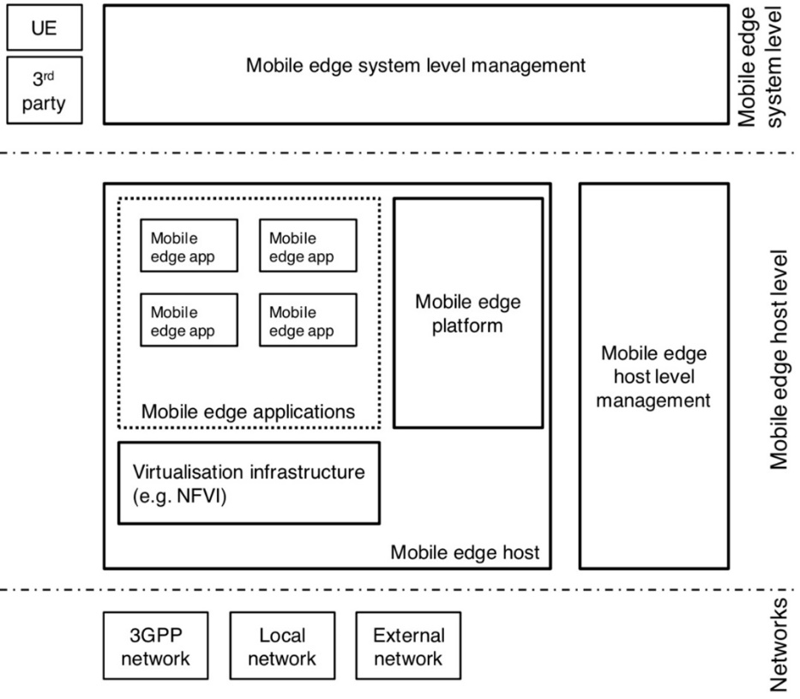
Figure 6.2.3.2-1: MEC framework [i.6]

Figure 6.2.3.2-2 illustrates the MEC reference architecture defined in the GS MEC 003 [i.6]. The reference architecture shows the functional elements that comprise MEC system and the reference points between them.
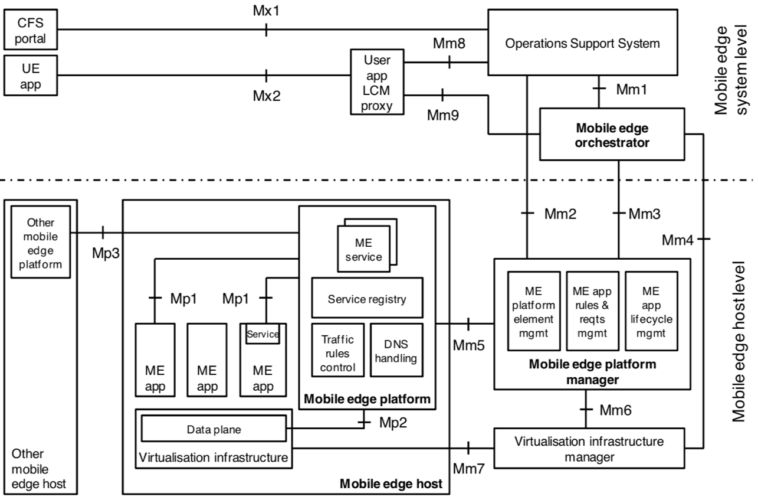
Figure 6.2.3.2-2: MEC reference architecture [i.6].

The reference architecture comprises mainly the following functions (those functions with reference points are further described in GS MEC 003 [i.6]):
Mobile edge host: The Mobile edge host comprises a Mobile edge platform and a Virtualisation infrastructure which provides compute, storage, and network resources for the mobile edge applications.
Mobile edge platform: The Mobile edge platform is the collection of essential functionality required to run Mobile edge applications and enable them to discover, advertise, consume, and offer mobile edge services via Mp1 reference point. It also communicates other Mobile edge host through the Mp3 reference when supported.
Mobile edge applications: The Mobile edge applications run as the virtual machines (VM) of the Mobile edge host. They interact with the Mobile edge platform to consume and provide mobile edge services via Mp1 reference point.
Virtualisation infrastructure: The Virtualisation infrastructure includes a data plane that executes the traffic rules received by the mobile edge platform, and routes the traffic among applications, services, DNS server/proxy, 3GPP network, local networks and external networks.
OSS (Operations Support System): The OSS receives requests via the CFS (Customer Facing Service portal) portal and from UE applications for instantiation or termination of applications and communicates with the Mobile edge orchestrator via Mm1 reference point for further processing.
Mobile edge orchestrator: The Mobile edge orchestrator is the core component of Mobile edge system level. It maintains an overview of the mobile edge system, on-boards of application packages, validates application rules and requirements, triggers application instantiation and termination, and selects appropriate mobile edge host(s).
Mobile edge platform manager: The Mobile edge platform manager manages the life cycle of applications, provides element management functions to the mobile edge platform and manages the application rules and requirements. It also receives fault reports and performance measurements from the virtualisation infrastructure manager.
Virtualisation infrastructure manager: The Virtualisation infrastructure manager allocates, manages and releases the virtualized resources (compute, storage and networking) of the virtualisation infrastructure via Mm7 reference point. It also collects and reports performance and fault information about the virtualised resources.
User application LCM proxy: The User application LCM (lifecycle management) proxy allows UE applications to request on-boarding, instantiation, termination of user applications via Mx2 reference point. It also authorizes requests from UE applications in the UE and interacts with the OSS via Mm8 reference point and the Mobile edge orchestrator via Mm9 reference point for further processing of these requests.

MEC API Specifications
ISG MEC defines a set of standardized APIs to support ege computing interoperability. The published API specifications comprise generic set of API design principles and patterns, management related APIs (system, host and platform management, and application lifecycle management), application enablement API, service related APIs (Radio Network Information, Location, UE Identity, and Bandwidth Management), and UE application interface. Figure 6.2.3.3-1 shows the mapping between MEC API specifications and MEC reference architecture [i.16].
Figure 6.2.3.3-1: Mapping between MEC API specifications and MEC reference architecture [i.16]

Generic set of API design principles and patterns, “GS MEC 009” [i.7]
Generic set of API design principles and patterns is defined in GS MEC 009 [i.7]. It also specifies guidance for MEC API documentation. Compliance with these principles ensures consistency across APIs.

System, Host and Platform management APIs, “GS MEC 010-1” [i.8]
Platform management API focuses on Mm2 reference point between the OSS and Mobile edge platform manager, defined in GS MEC 010-1 [i.8]. The API provides platform management related functionality, such as configuration management and fault management, using 3GPP defined IRPs (Integration Reference Point) [i.22], [i.23], [i.24], [i.25].

Application lifecycle management (LCM) APIs, “GS MEC 010-2” [i.9]
Application LCM API using Mm1 and Mm3 reference points is defined in GS MEC 010-2 [i.9]. Mm1 reference point between Mobile Edge Orchestrator and OSS is used for on-boarding application packages, triggering application instantiation and termination. Mm3 reference point between the Mobile edge orchestrator and the Mobile edge platform manager is used for the management of the application lifecycle, application rules and requirements, and keeping track of available mobile edge services.
Figure 6.2.3.3.3-1 illustrates the message flow of application instantiation. The OSS sends an instantiate application request to Mobile edge orchestrator via Mm1 (Step-1). Then Mobile edge orchestrator checks the application instance configuration data and authorizes the request via Mm3. It also selects the Mobile edge host, and sends an instantiate application request to the Mobile edge platform manager (Step-2). The Mobile edge platform manager communicates with Mobile edge platform and Virtualization infrastructure manager for resource allocations and configuration request of Traffic/DNS rules (Step-3,4,5 and 7 are not specified in GS MEC 010-2 [i.9]). The configuration (Step 6) between Mobile edge platform and Mobile edge application instance is specified in GS MEC 011 [i.10].
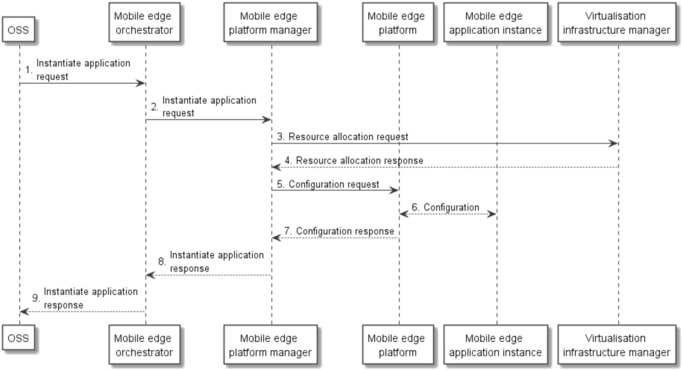
Figure 6.2.3.3.3-1: Application instantiation flow [i.9]

Application Enablement API, ”GS MEC 011” [i.10]
Application Enablement API is specified in GS MEC 012 [i.10] and supports the requirements in GS MEC 002 [i.5]. It focuses on Mp1 reference point between Mobile edge application and Mobile edge platform, which provides service related functionality, such as registration, discovery and service availability. It also provides other functionality, such as application start-up/termination, available transports, traffic rules (e.g. traffic filter per flow or packet and priority of traffic rule), DNS rules activation, and access to time of day information (e.g. NTP and PTP).

Radio Network Information service (RNIS) API, ”GS MEC 012” [i.11]
RNIS API is specified in GS MEC 012 [i.11] and supports the requirements in GS MEC 002 [i.5]. It provides radio network related information to Mobile edge application and Mobile edge platform in order to optimize the existing services and to provide new type of services that are based on up to date information on radio conditions. RNIS is discovered over the Mp1 reference point.
The information provided by RNIS classified as follow:
RAB (Radio Access Bearer) information: It includes information on existing RAB, RAB establishment, RAB modification, and RAB release. The existing RAB information includes the information on users per cell such as:
- The identifiers of the cells (E-UTRAN cell global identifier [i.17]).
- The identifiers associated to UEs in the cells.
- The E-RAB information based on E-RAB ID (identifying a radio access bearer for a particular UE) [i.17], QCI [i.21], and QoS (Maximum downlink/uplink E-RAB Bit Rate and guaranteed downlink/uplink E-RAB Bit Rate) [i.21].
PLMN (Public Land Mobile Network) information: It includes cell level PLMN information related to specific mobile edge application instance (e.g. E-UTRAN cell global identifier [i.17] and PLMN Identity [i.17]).
S1 bearer information: It is used for optimizing the relocation of mobile edge applications or managing the traffic rules for the related application instances. It contains following information: E-UTRAN cell global identifier [i.17], PLMN Identity [i.17], and S1 bearer information (E-RAB ID [i.17] (identifying a S1 bearer for a specific UE), eNB transport layer address, eNB GTP-U TEID, S-GW transport layer address and S-GW GTP-U TEID).
Cell change information: It is sent by the RNIS to inform about the cell change of a UE. It includes the following information: handover status (e.g. in preparation, in execution, completed and rejected), E-UTRAN cell global identifier [i.17] and PLMN Identity [i.17] for the source/target cell.
UE measurement reports: It includes as follow: E-UTRAN cell global identifier [i.17], PLMN Identity [i.17], triggers for the measurement report (e.g. periodical, not available) [i.19], Reference Signal Received Power [i.18] and Reference Signal Received Quality [i.18] for the source cell and neighbouring cells.
UE timing advance: RNIS provides the Timing Advance value received from the UE in order to ensure that uplink and downlink sub frames are synchronized at the eNB. It contains following information: E-UTRAN Cell Identity [i.17], PLMN Identity [i.17], and Timing Advance [i.18].
Figure 6.2.3.3.5-1 shows a deployment scenario where Mobile edge application acquires RNIS from S1 interface. Regarding other deployment scenarios, see MEC deployments White Paper [i.30].
Figure 6.2.3.3.5-1: Mobile edge application acquires RNIS from S1 IF

Location service (LS) API, ”GS MEC 013” [i.12]
LS API is specified in GS MEC 013 [i.12] and supports the requirements in GS MEC 002 [i.5]. It provides the location related information to Mobile edge application and Mobile edge platform. LS supports the location retrieval mechanism, the location subscribe mechanism, the anonymous location report (e.g. for statistics collection), and the location information. LS is registered and discovered over the Mp1 reference point.
LS leverages the Zonal Presence service described in SCF 084.07.01 [i.26] and in SCF 152.07.01 [i.27]. LS is accessible through the API defined in the Open Mobile Alliance (OMA) specification "RESTful Network API for Zonal Presence"[i.28]. In the GS MEC 013 [i.12], Anonymous Customer Reference (ACR) [i.29] is applied on addressing particular user categories, and 3GPP Cell Identifiers defined in 3GPP TS.29.171 [i.20] can be mapped to the Access Point identifier of the OMA API [i.28].
The location information provided by LS contains as follow (specified in OMA API [i.28]): address of user (e.g. 'acr' URI) currently on the access point, the identity of the access point the user is currently on, the identity of the zone the user is currently within, the geographical coordinates where the user is and contextual information of a user location (e.g. aisle, floor, room number, etc).

UE Identity service API, “GS MEC 014” [i.13]
UE Identity service API is specified in GS MEC 014 [i.13] and supports the requirements in GS MEC 002 [i.5]. The UE Identity feature is to allow UE specific traffic rules in the mobile edge system. Each UE is identified by a unique tag and the tag registration triggers the Mobile edge platform to activate the corresponding traffic rules. Mp1 reference point is used for the UE Identity functionality.

Bandwidth Management service (BWMS) API, “GS MEC 015” [i.14]
BWMS API is specified in GS MEC 015 [i.14] and supports the requirements in GS MEC 002 [i.5]. It enables registered applications to statically and/or dynamically register for specific bandwidth allocation (bandwidth size, bandwidth priority, or both) per session/application. BWMS is registered over Mp1 reference point.
The information provided by BWMS contains as follow: request type (application specific bandwidth allocation or session specific bandwidth allocation), indicating bandwidth allocation priority when dealing with several applications or sessions in parallel, size of bandwidth allocation, and the direction of the requested bandwidth allocation (downlink, uplink or symmetrical).

UE application interface, “GS MEC 016” [i.15]
UE application interface is specified in GS MEC 016 [i.15] and provides the LCM of the user applications API to support the requirements defined in GS MEC 002 [i.5]. It supports the request for the list of available user applications, the request for the user application instantiation, and the request for the user application termination over Mx2 reference point between the UE application in the UE and the user application LCM proxy.
The information provided by the request procedure for the list of available user application contains as follow: application name, application provider, application software version, description of application, characteristics of application, maximum memory size, maximum storage size, latency, required connection bandwidth, service continuity mode (required or not required), vendor specific information, and vendor identifier.

Technology x

oneM2M Architectural Framework
Editor’s Note: The section provides an analysis of the oneM2M architectural framework needed for employing Edge and Fog technologies in oneM2M. It also includes descriptions of the optimizations which Edge and Fog Computing are expected to provide to oneM2M implementations.

Introduction
Editor’s Note: This section provides an introduction to the framework developed for employing Edge and Fog technologies in oneM2M. Key terminology should be formalized for use in all subsequent sections.

oneM2M Platform Optimization Scenarios
Editor’s Note: This section provides scenarios where Edge and Fog technologies are sought to bring optimizations to oneM2M platform implementations. It is recommended that each scenario is used to derive one or more Key Issues.

Architectural Models and Assumptions
Editor’s Note: The section provides examples of architectural models derived from analysis and the associated assumptions. These models may be used for example in section 9 to provide the assumptions made and a frame of reference for the solutions proposed.

Model A

Introduction
This model uses as main inputs the terminology and frameworks provided by ETSI MEC and OpenFog, and seeks to:
- Introduce oneM2M terminology that reflects the oneM2M Service Layer focus, while being consistent with the existing work in the Edge/Fog domain.
- Provide a framework for using Edge/Fog technologies in oneM2M with minimal impact on the existing architecture.
In Model A the Edge and Fog technologies considered are seen as enablers mapped to functionality within the existing oneM2M entities, which can be realized by functional and deployment options.

Proposed Terminology
Fog Deployment: Hierarchical, scalable collection of nodes, which supports enhanced levels of autonomous functionality at the field nodes.
Autonomous functionality enables fog nodes to continue delivering functionality in the case of external service degradation or failures. The autonomy functions can include discovery, orchestration and management, security, operation and cost savings, which do not rely on a centralized operation entity.
Fog deployments can include characteristics/capabilities such as:
- Individual fog nodes can scale internally, through the addition of hardware or software.
- Placement of applications allowing system optimizations
- A deployment of fog nodes can be scaled up or down in a demand-driven elastic environment.
- Storage, network connectivity, and analytics services can scale with the fog infrastructure.
Fog deployments are implemented by deploying “Fog Deployment Enablement” services.
Cloudlet Deployment: Scalable collection of nodes using virtualisation technology to provide distributed compute, storage and network resources for cloud/infrastructure services, closer to the end field nodes.
Cloudlet deployments are implemented by deploying “Cloudlet Deployment Enablement” services.
Fog Deployment Enablement (FDE) Service: service that provides support for functionality targeting the enablement of Fog deployments, such as:
- Remote instantiation of Fog Services, as well as the remote provisioning of information required to instantiate the services.
- Sharing and discovery of Fog Service capability information
- Requests for Fog Services to be provided by specific nodes.
- Fog Service continuity and migration among nodes.
- Orchestration of Fog Services provided by nodes in a deployment in a dynamic fashion to satisfy operational requirements
A oneM2M Node with FDE capabilities is also termed a Fog Node.
Cloudlet Deployment Enablement (CDE) Service: service which relies upon platform & virtualisation infrastructure to provide support (including compute, storage, and network resources) for the instantiation of cloud applications and services closer to the end devices.
A oneM2M Node with CDE capabilities is also termed a Cloudlet Node.
Endpoint: A Field Node in a Cloudlet or Fog deployment which does not provide services to any other node. Architecturally, endpoints can be ASNs, ADNs or NoDNs.
Local Fog Node: A Field Node with FDE capabilities which provides services to at least one Endpoint in a Fog deployment. Architecturally, LFNs can be MNs or ASNs.

Deployment Example
Figure 7.3.1.3-1 depicts an example deployment showing relationships between capabilities and roles of the nodes within the deployment, using the Model A proposal. Not all options are depicted.
Figure 7.3.1.3-1 Example deployment for Model A

Analysis
Editor’s Note: This section details Key Issues for employing Edge and Fog technologies for oneM2M deployments.

Key Issue 1
Editor’s Note: Each Key Issue description references either optimization scenarios (section 7.2), use-cases from one of the relevant TRs (e.g. TR-0001, TR-0018, etc.) or requirements (TS-002) and concludes with a succinct statement defining the issue.

Key Issue N

Proposed Solutions
Editor’s Note: The section provides solutions to the Key Issues identified for employing Edge and Fog technologies in oneM2M.

Solution A
Editor’s Note: Each Solution section references one or more Key Issues that it addresses and provides a brief solution description.

Solution Applicability
Editor’s Note: The Solution Applicability states which Key Issues are addressed by the solution.

Solution Description
Editor’s Note: This section provides a concise description of the solution which provides enough detail for further stage 2 development.

Solution X

Conclusions
Editor’s Note: This section provides a summary of the conclusions drawn during the study.

Annexes
Each annex shall start on a new page (insert a page break between annexes A and B, annexes B and C, etc.).
Use the Heading 9 style for the title and the Normal style for the text.
Annex <A>:
Title of annex (style H9)
<Text>
<PAGE BREAK>

History
Publication history
V.1.1.1 | <dd Mmm yyyy> | <Milestone>

Draft history (to be removed on publication)
V0.0.1 | 2018-03-15 | Skeleton of the TR.
V0.1.0 | 2018-03-23 | Merges of agreed the following contributions at REQ#34, ARC#34 and SEC#34.  1. REQ-2018-0025R01 Introduction to NIST.
V0.2.0 | 2018-06-10 | Merges of agreed the following contributions at REQ#35, ARC#35 and SEC#35.  1. ARC-2018-0105 Introduction to OpenFog.  2. ARC-2018-0099R01 ETSI ISG MEC Architecture and APIs for TR-0052..
V0.3.0 | 2018-08-09 | Merges of agreed the following contributions at REQ#36 and ARC#36, and editorial updates.  ・ARC-2018-0203R02 TR-0052 Edge Fog nomenclature.

